How do we have WIFI in the middle of this desolate hellscape???

Black Rock City needs reliable Internet connectivity for several organizational functions (ticketing, logistics, medical, public safety, etc.).

The Burning Man Network Operations Team provides this through a variety of technologies that are designed to operate in this complex environment and obtain connectivity back to “civilization” (commercial Internet fiber peering and transit).

This is a challenging but critical function, one of many parts of the incredible behind-the-scenes engineering effort that happens each year to make Burning Man possible.

The Network Operations Team (thanks Cat -^..^- !!) provides surplus bandwidth as a gift to camps, to support their art and to offer to participants.

Connectivity is blanketed across the playa using a series of directional point-to-multipoint radios on a 60ft tower near Center Camp. These radios use a special protocol similar to (but not identical to) 5ghz WiFi to optimize for reliable distribution to camps:
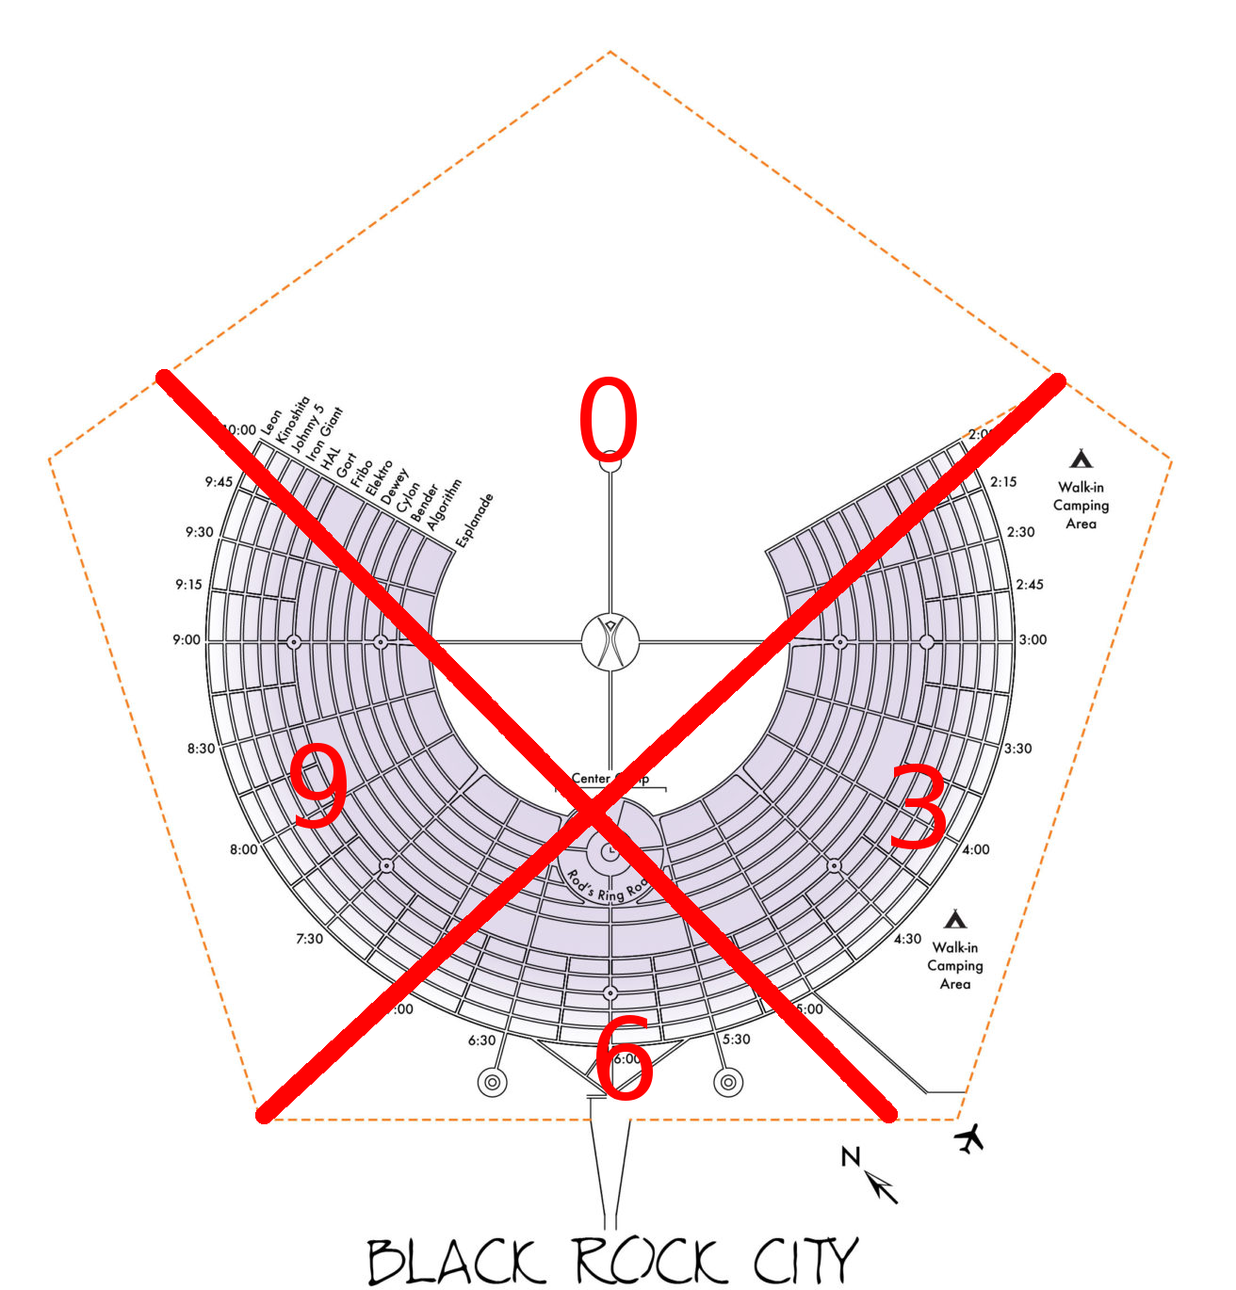

Camps that want connectivity must:
1.) Obtain and configure a compatible radio
2.) Safely obtain line-of-sight to the Center Camp tower
3.) Provide the radio with a reliable source of power
4.) Provide some mechanism (2.4ghz wifi, etc…) for distributing connectivity within their camp.

Engineering in this complex environment is part of our artistic expression and our gift to fellow participants.

We’re glad that you’ve stopped by!

